# Techorama Forms demo

## Android

Giant memory leak:

For example:

If u go from page 1 to page 2 and on page 2 we show 100 images we use a lot of memory. If we then navigate back the memory stays in use. This only gets cleared when u navigate forward. So if you do this navigation page 1-> 2->3->4->5 and then 1<-2<-3<-4<-5 the app keeps 4 pages in memory. If you then navigate to page 6 it will get cleared.

<https://github.com/xamarin/Xamarin.Forms/blob/master/Xamarin.Forms.Platform.Android/Platform.cs#L459>

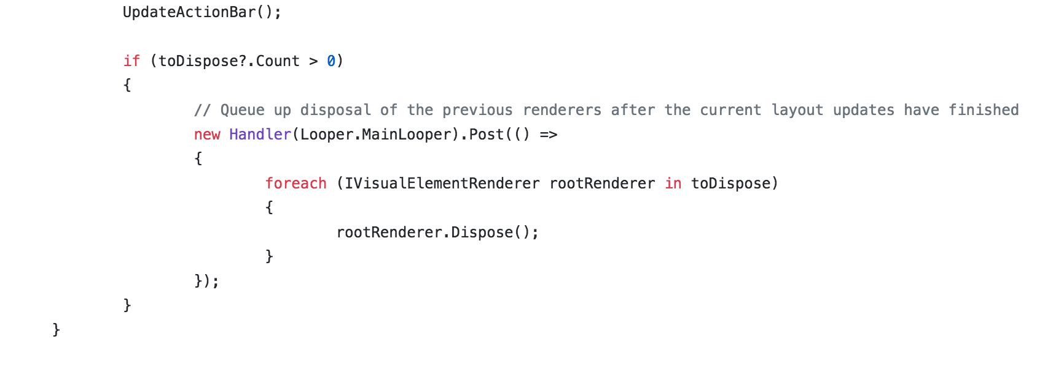

Second the handler in the already bad code above misuses the Hanlder class which can cause thread locks. It should first check if it is already on the main thread.